**Practical 02 How to create device, Add Modules & Make connections in Packet Tracer**

* **Create device: -**
* We can choose any type of devices such as end devices, switches, routers etc.… from the device-type selection box.

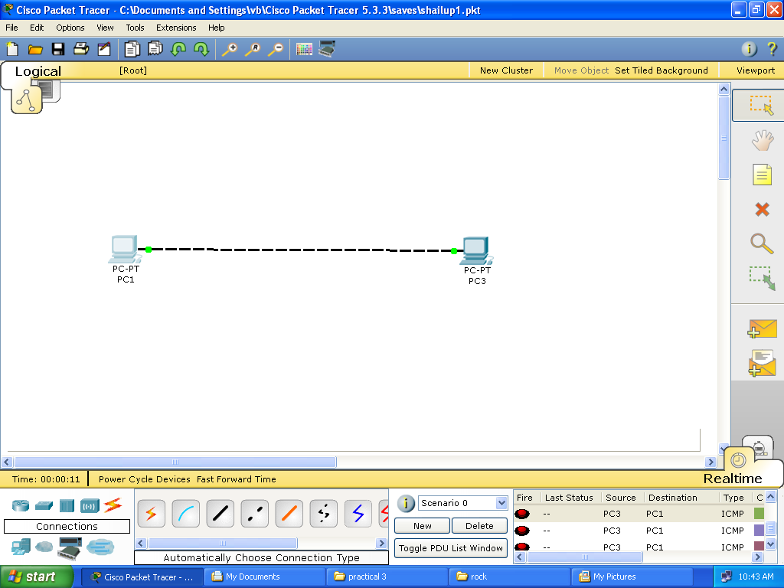

* **Add modules:-**
* In some routers, both in real and in CPT, we can add modules to get some extra ports.
* In Cisco Packet Tracer, to add modules to your Cisco Router, go to Physical Tab and under Modules Tab, you will see the available modules.
* If you want to add the module, you just have to drag and drop the modules into the available slot.

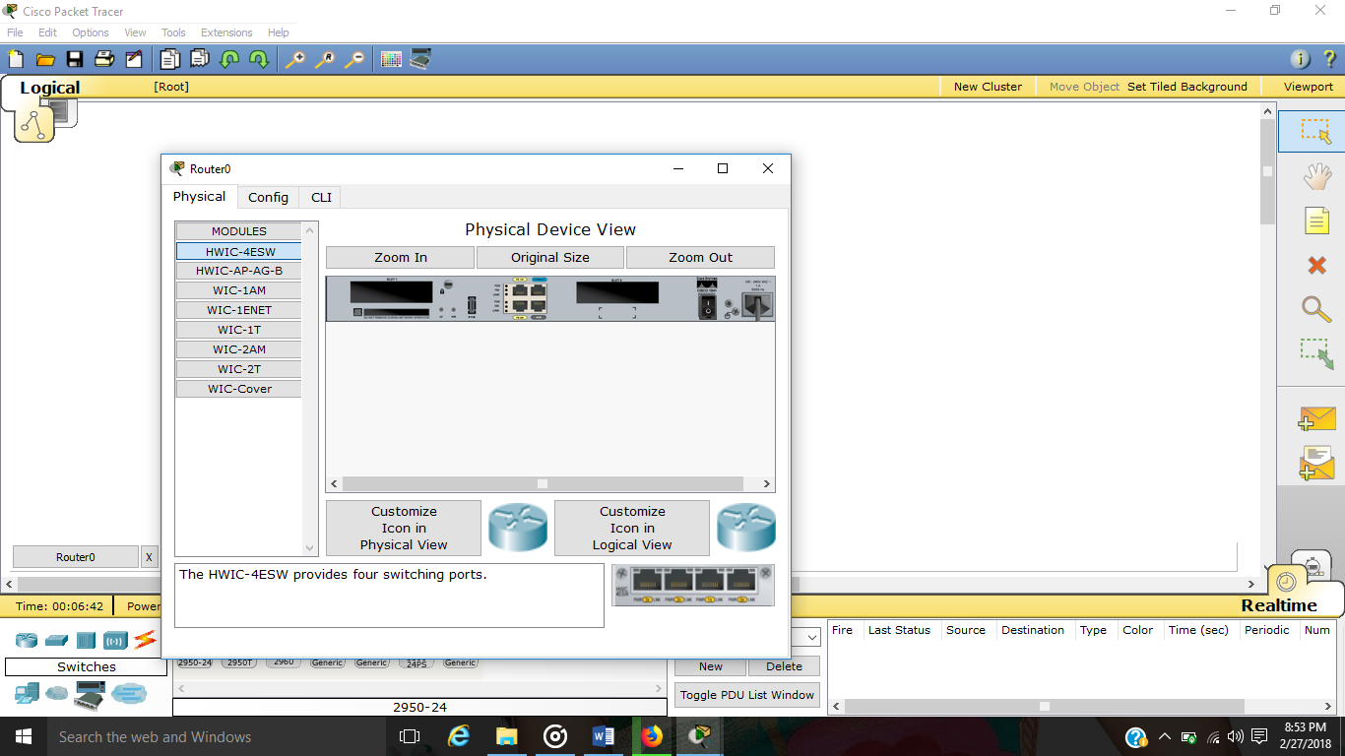

* **Make connections:-**
* Choosing the Connections icon from the device-type selection box lists several cables in the device-specific selection box such as console, copper straight through, fiber etc.…
* It also provides automatic connection type which detects type of system and then connects through recommended connection type.

